Experiment 2 :

AIM: Working with Docker (Basic Commands)

Steps to Complete:

1. Search a Redis image on DockerHub
2. 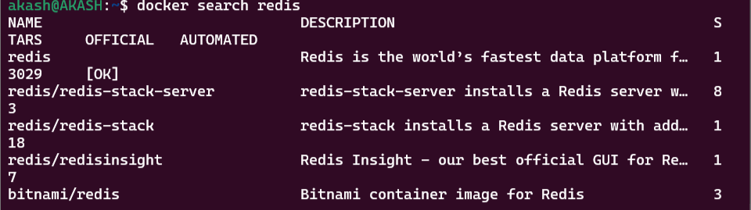

2. Run Docker Container of Redis Image in background

3. Run Docker PS and Docker PS –a

4. Run Docker Container and take its console

